Python(22AIE205) Programming Lab

Weekly Lab Report-1

LAB 1: INPUT, OUTPUT AND ARITHMETIC OPERATIONS.

Name: | C.Pranaveswar
Roll No. | AIE25102
Section: | AIE-B
Department: | Artificial Intelligence and Engineering
Experiment Date:

Experiment Record:
Date: | 14-07-2026
Experiment Name: | INPUT, OUTPUT AND ARITHMETIC OPERATIONS
Aim: | To practise keyboard input, formatted output, type conversion, arithmetic operators, floor division, modulus, and exponentiation using Python IDLE.
Software Required: | Python 3.x and Python IDLE

Questions Given:
The following questions were assigned for Lab 1. The detailed programs and sample outputs are presented in the next section.
Question 1: Printing Personal Details - Write a Python program to accept and display the student name, registration number, age, department, university name, and city. Also print one sentence using an f-string.
Question 2: Sum of Two Numbers - Accept two integers from the user and display their sum.
Question 3: Basic Arithmetic Operations - Accept two numbers and display their sum, difference, product, quotient, floor quotient, remainder, and power.
Question 4: Square and Cube - Accept one number and calculate its square and cube using the exponentiation operator (**).
Question 5: Simple Interest - Accept principal amount, annual rate of interest, and time period. Calculate the simple interest and total amount.
Question 6: Area of a Triangle - Accept the base and height of a triangle and calculate its area.
Question 7: Kilometre Conversion - Accept a distance in kilometres and convert it into metres and centimetres.
Question 8: Salary Calculation - Accept the basic salary, house rent allowance (HRA), and travel allowance. Calculate and display the gross salary.
Question 9: Minutes Conversion - Accept total minutes and convert them into hours and remaining minutes using floor division (//) and modulus (%).
Question 10: Seconds Conversion - Accept total seconds and convert them into hours, minutes, and remaining seconds using // and %.
Question 11: Product Bill - Accept product name, quantity, and price per item. Calculate the subtotal, 5% tax, and final payable amount.
Question 12: Room Area, Perimeter and Total Flooring Cost - Accept the length and breadth of a classroom and the flooring cost per square metre. Display the area, perimeter, and total flooring cost using f-strings with two decimal places.
Programs, Sample Outputs and Results:
Question 1: Printing Personal Details
Problem Statement: Write a Python program to accept and display the student name, registration number, age, department, university name, and city. Also print one sentence using an f-string.
Program:
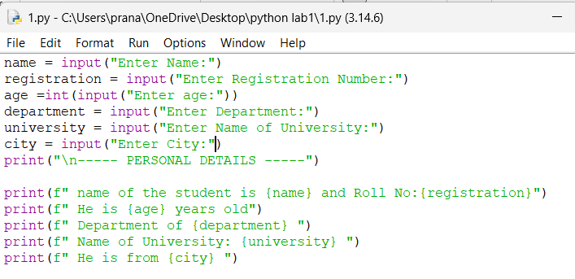
Input and Output:
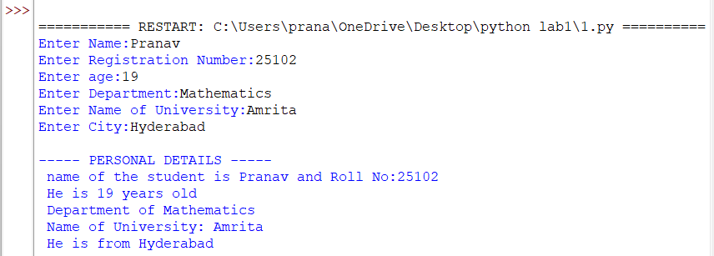
Result: The program accepted and displayed the student details successfully using input(), print(), and an f-string.
Question 2: Sum of Two Numbers
Problem Statement: Accept two integers from the user and display their sum
Program:
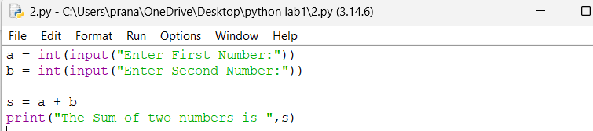
Input&Output:
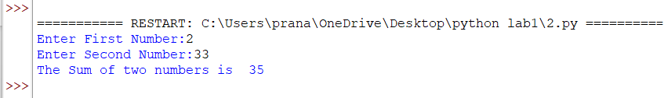
Result: The sum of the two entered integers was calculated and displayed correctly.
Question 3: Basic Arithmetic Operations
Problem Statement: Accept two numbers and display their sum, difference, product, quotient, floor quotient, remainder, and power.
Program:
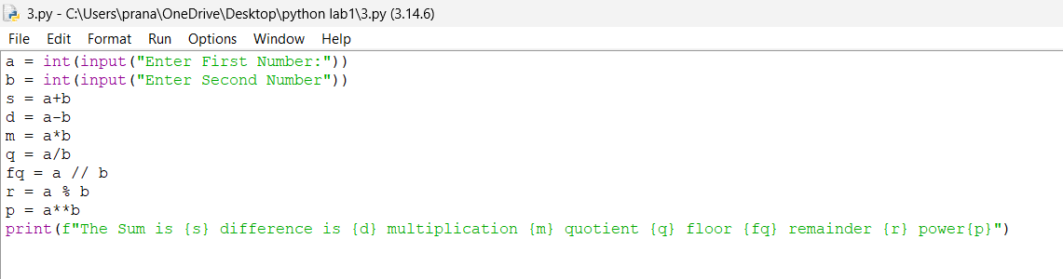
Input&Output:
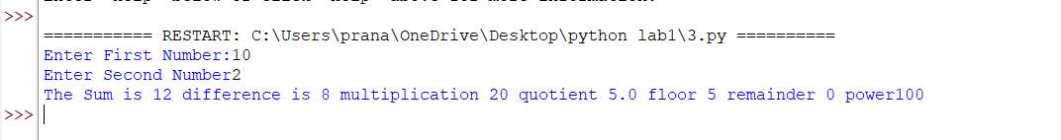
Result: All seven arithmetic operations were performed and displayed correctly.
Question 4: Square and Cube
Problem Statement: Accept one number and calculate its square and cube using the exponentiation operator (**).
Program:
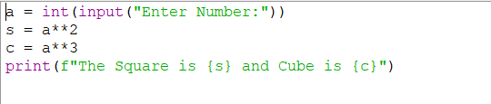
Input&Output:
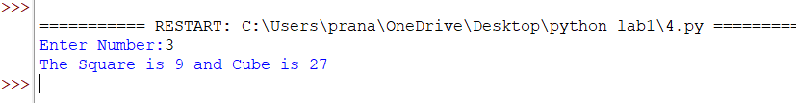
Result: The square and cube of the entered number were calculated using the exponentiation operator.
Question 5: Simple Interest
Problem Statement: Accept principal amount, annual rate of interest, and time period. Calculate the simple interest and total amount.
Program:
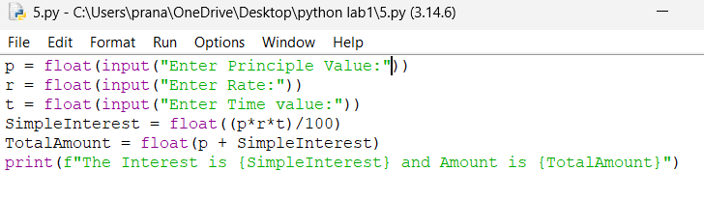
Input&Output:
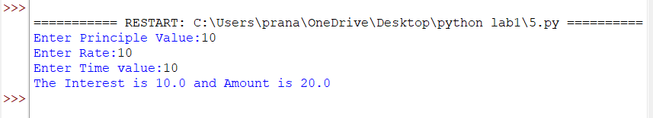
Result: The simple interest and total amount were calculated correctly from the entered values.
Question 6: Area of a Triangle
Problem Statement: Accept the base and height of a triangle and calculate its area.
Program:
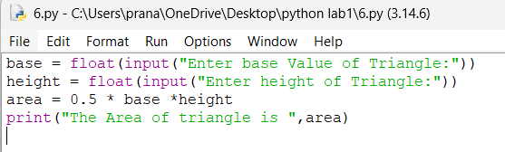
Input&Output:
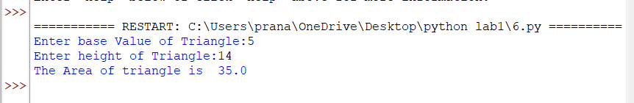
Result: The area of the triangle was calculated successfully using 0.5 x base x height.
Question 7: Kilometre Conversion
Problem Statement: Accept a distance in kilometres and convert it into metres and centimetres.
Program:
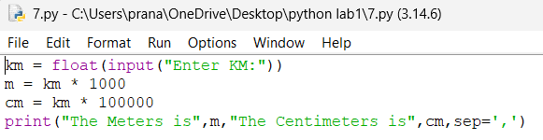
Input&Output:
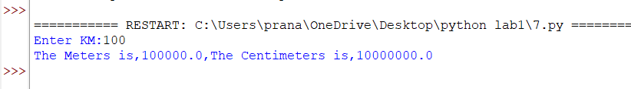
Result: The entered distance was converted correctly into metres and centimetres.
Question 8: Salary Calculation
Problem Statement: Accept the basic salary, house rent allowance (HRA), and travel allowance. Calculate and display the gross salary.
Program:
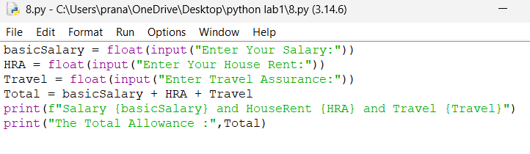
Input&Output:
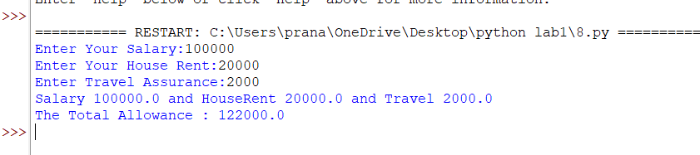
Result: The gross salary was calculated by adding the basic salary, HRA, and travel allowance.
Question 9: Minutes Conversion
Problem Statement: Accept total minutes and convert them into hours and remaining minutes using floor division (//) and modulus (%).
Program:
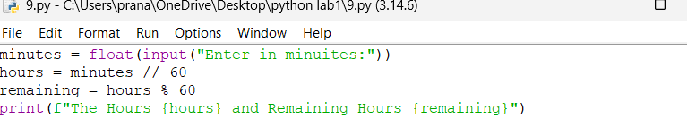
Input&Output:
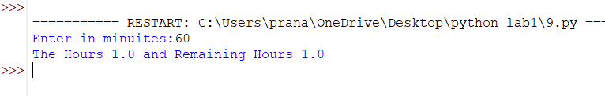
Result: The entered minutes were converted correctly into hours and remaining minutes.
Question 10: Seconds Conversion
Problem Statement: Accept total seconds and convert them into hours, minutes, and remaining seconds using // and %.
Program:
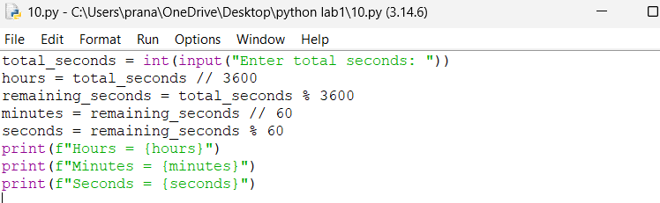
Input&Output:
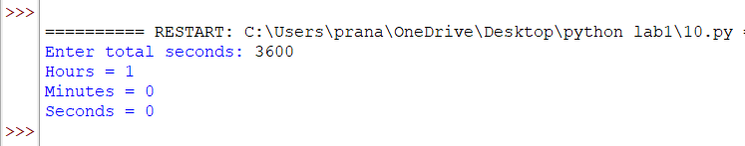
Result: The entered seconds were converted correctly into hours, minutes, and remaining seconds
Question 11: Product Bill
Problem Statement: Accept product name, quantity, and price per item. Calculate the subtotal, 5% tax, and final payable amount.
Program:
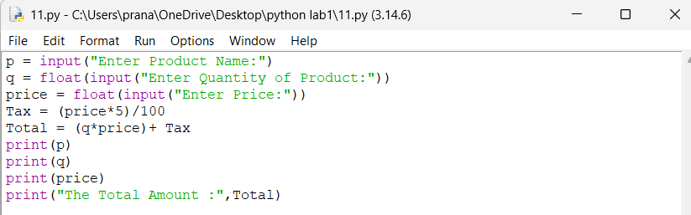
Input&Output:
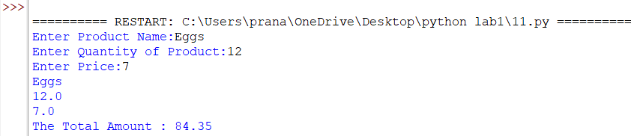
Result: The subtotal, tax, and final payable amount were calculated and displayed correctly.
Question 12: Room Area, Perimeter and Total Flooring Cost
Problem Statement: Accept the length and breadth of a classroom and the flooring cost per square metre. Display the area, perimeter, and total flooring cost using f-strings with two decimal places.
Program:
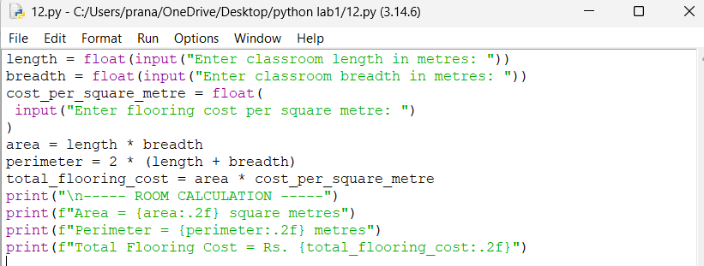
Input&Output:
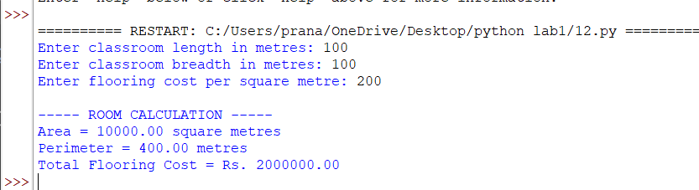
Observation:
• The input() function returns data as a string unless it is converted using int() or float().
• Commas in print() can display strings and numerical values together without explicit conversion.
• An f-string begins with the letter f and allows variables or expressions inside curly brackets.
• The / operator performs normal division, // gives the floor quotient, and % gives the remainder. • The ** operator is used for exponentiation, such as number ** 2 for the square.
• Formatting such as :.2f displays a floating-point value with two decimal places.
Overall Result:
All assigned programs for input, output, type conversion, and arithmetic operations were written and executed successfully in Python IDLE. The outputs were verified for the given sample inputs

